Lab: Need to access public network from Public subnet and access Public subnet from Public network.

Scenario:

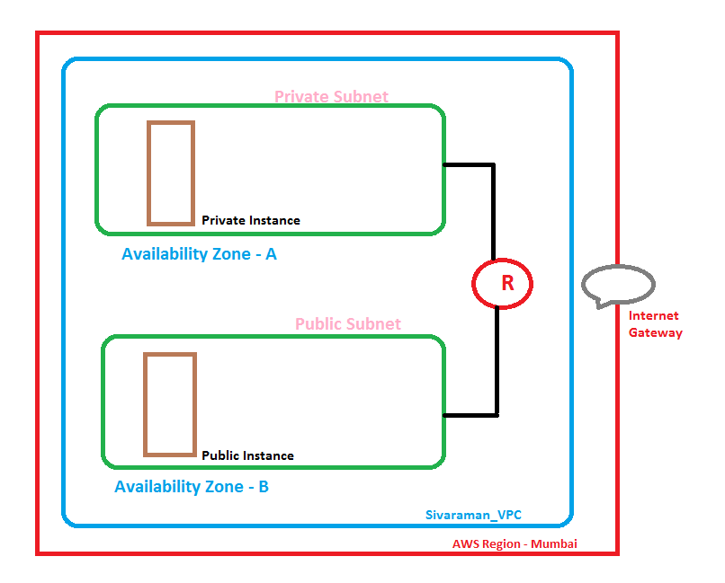

In Mumbai Region, We have required to create a VPC as “Sivaraman VPC”. In Sivaraman VPC, we need to create two subnets i.e. Private Subnet and Public Subnet. In public subnet we need to create an instance and private subnet also we need to create an instance. By default both availability zone will be communicate by using a router. Now we need to design VPC, Subnet and Subnet routing table and instances for the above scenario.

Please login to the aws console, <https://aws.amazon.com> by using your login credentials.

* While logged on to the AWS portal, please go to **Networking & Content Delivery**

**Then select “VPC”**

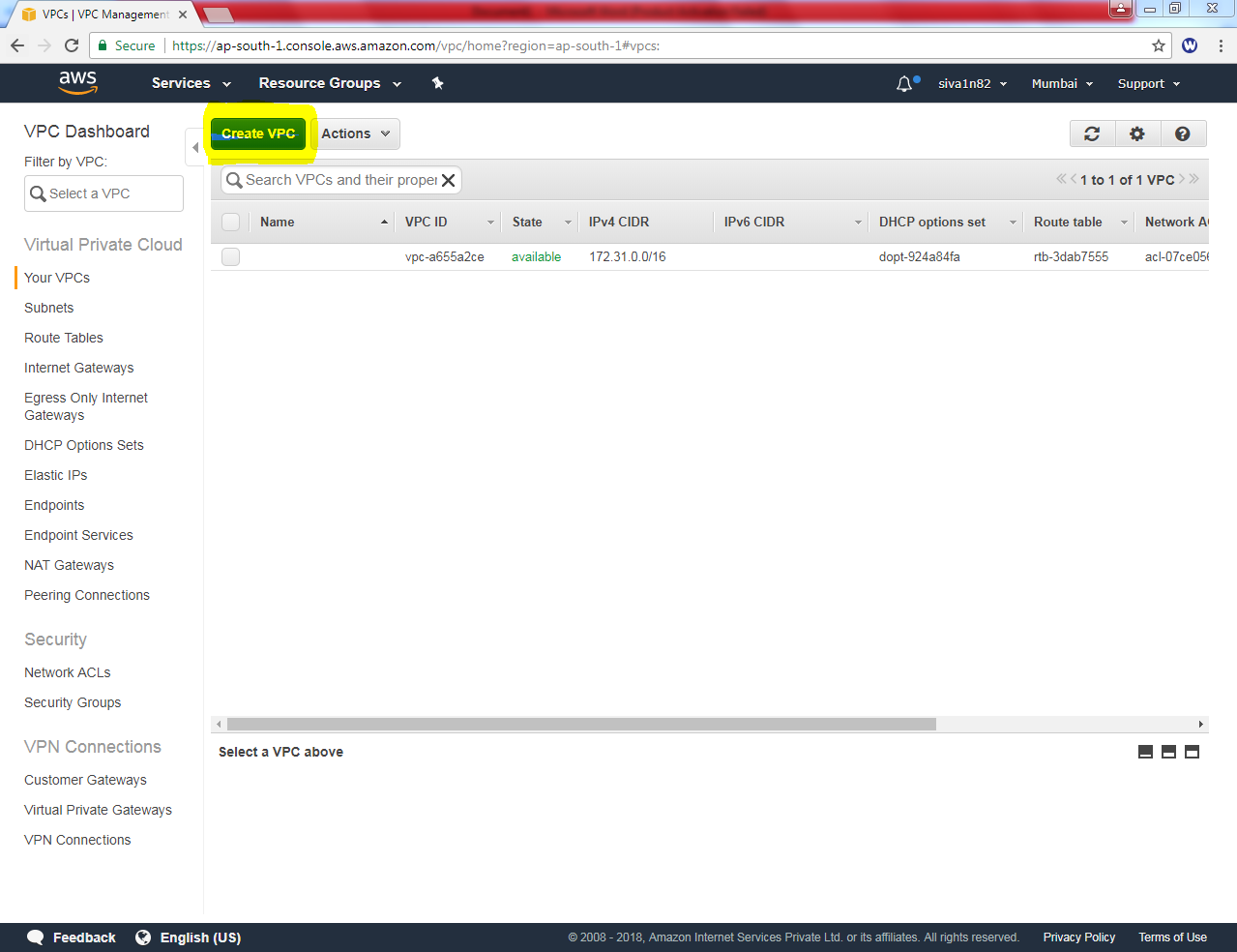

**Click “Create VPC”**

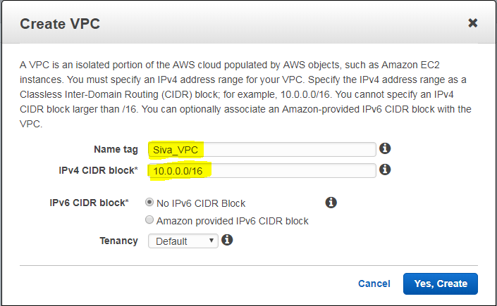

**While creating VPC, in Name Tag “Siva_VPC”and IPV4 CIDR block “10.0.0.0/16”. Then click “Yes create” button.**

**Now you can able to view the Siva VPC in VPC option.**

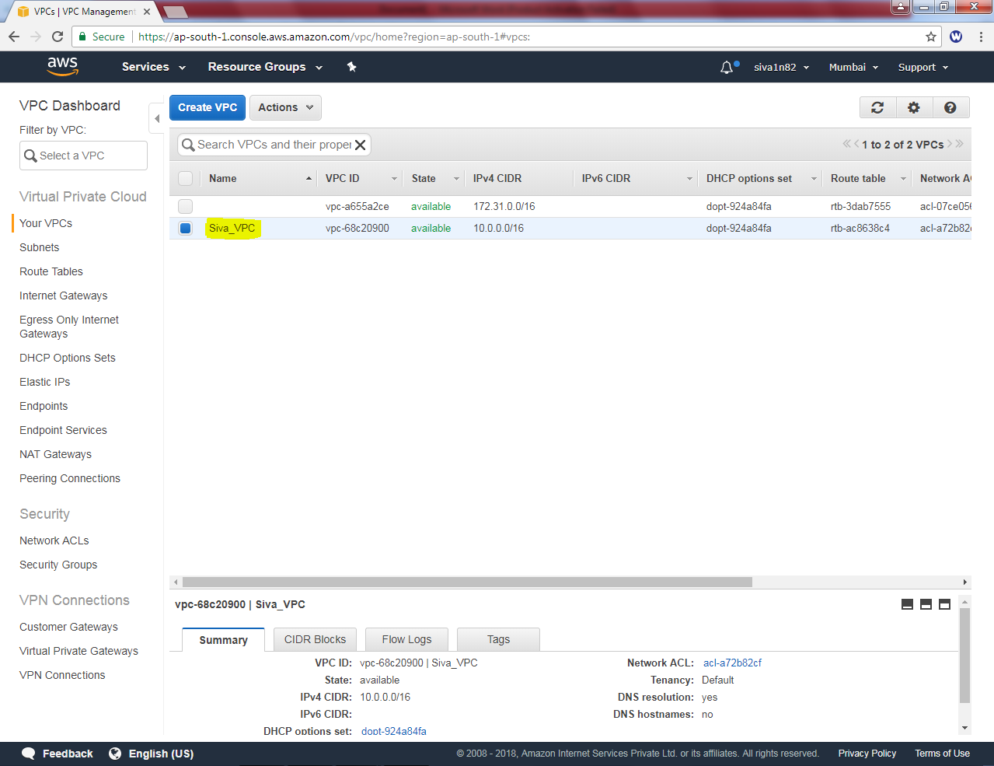

**Then we need to create subnet for VPC, i.e. Public Subnet and Private Subnet.**

**In Under VPC dashboard, “Subnets” option is there**

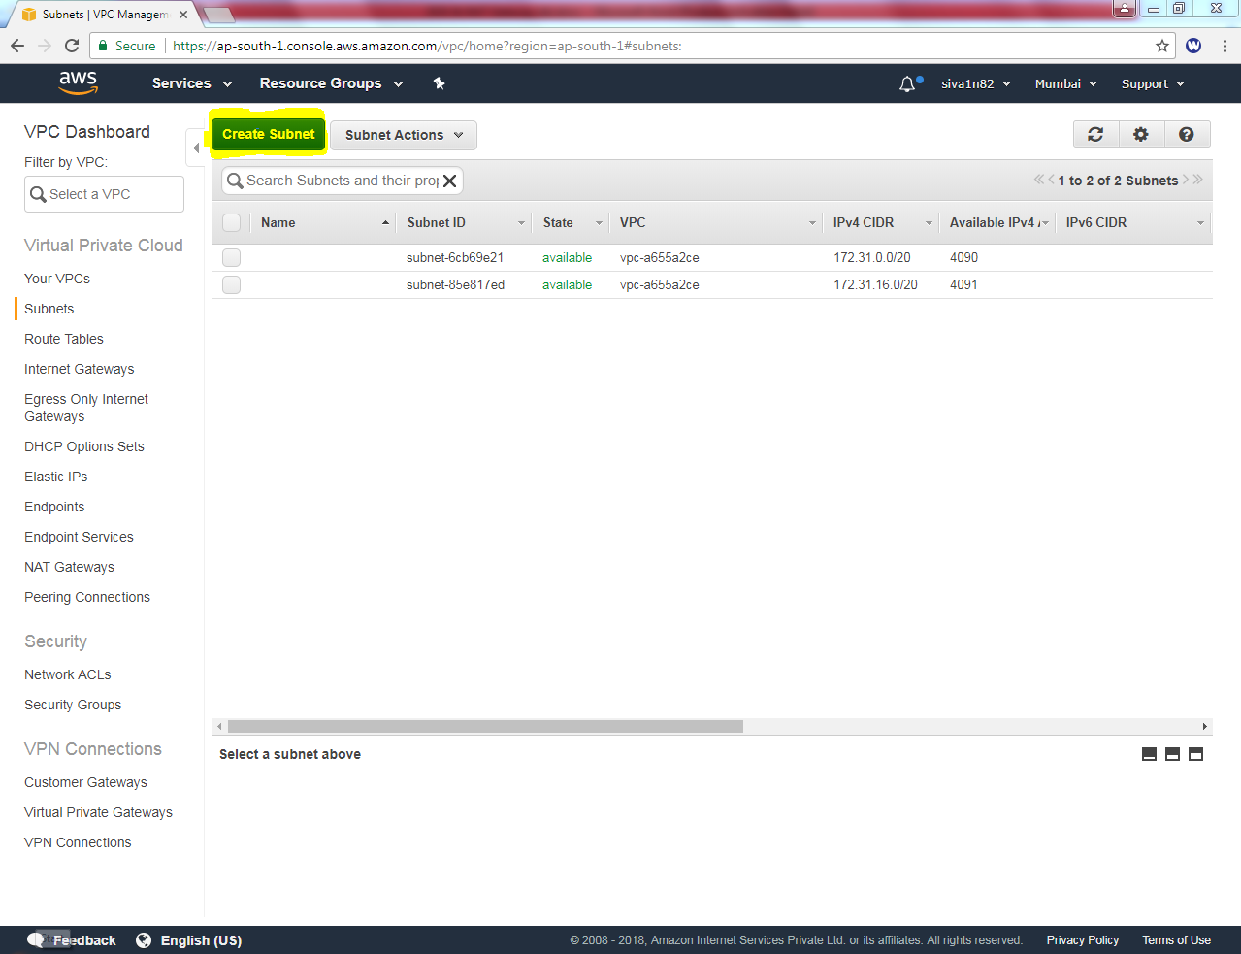

**Select “Create Subnet”**

**In Name Tag “Siva_Public_Network” , VPC Select “Siva_VPC”, Availablility Zone select “1B” and IPV4 CIDR BLOCK 10.0.2.0/24.**

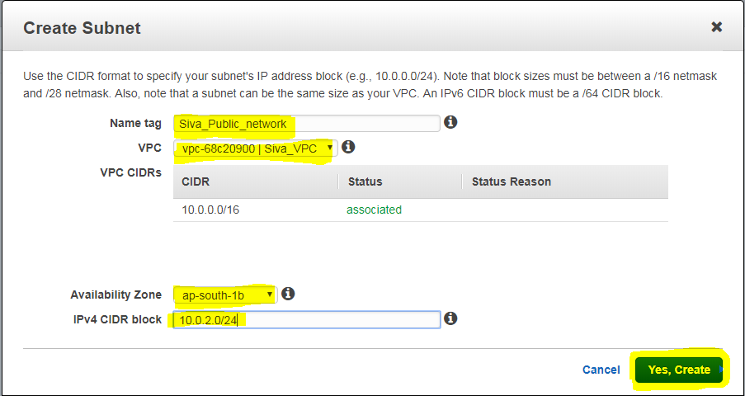

**Then click “Yes, Create”.**

**In Name Tag “Siva_Private_Network” , VPC Select “Siva_VPC”, Availablility Zone select “1A” and IPV4 CIDR BLOCK 10.0.1.0/24.**

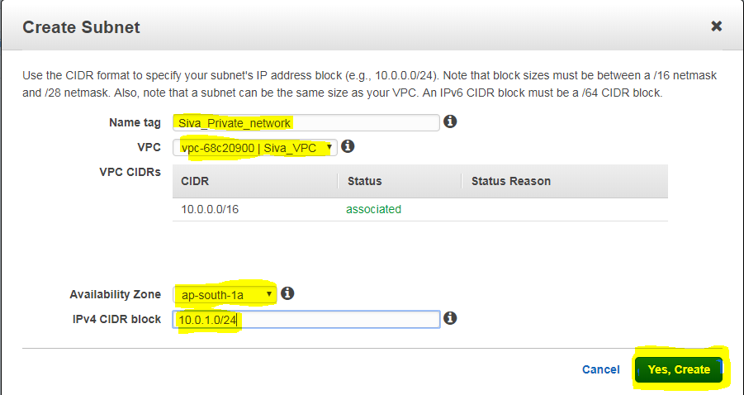

**Then click “Yes, Create”.**

**Now we need to create an instance, on public network. Click Launch Instance**

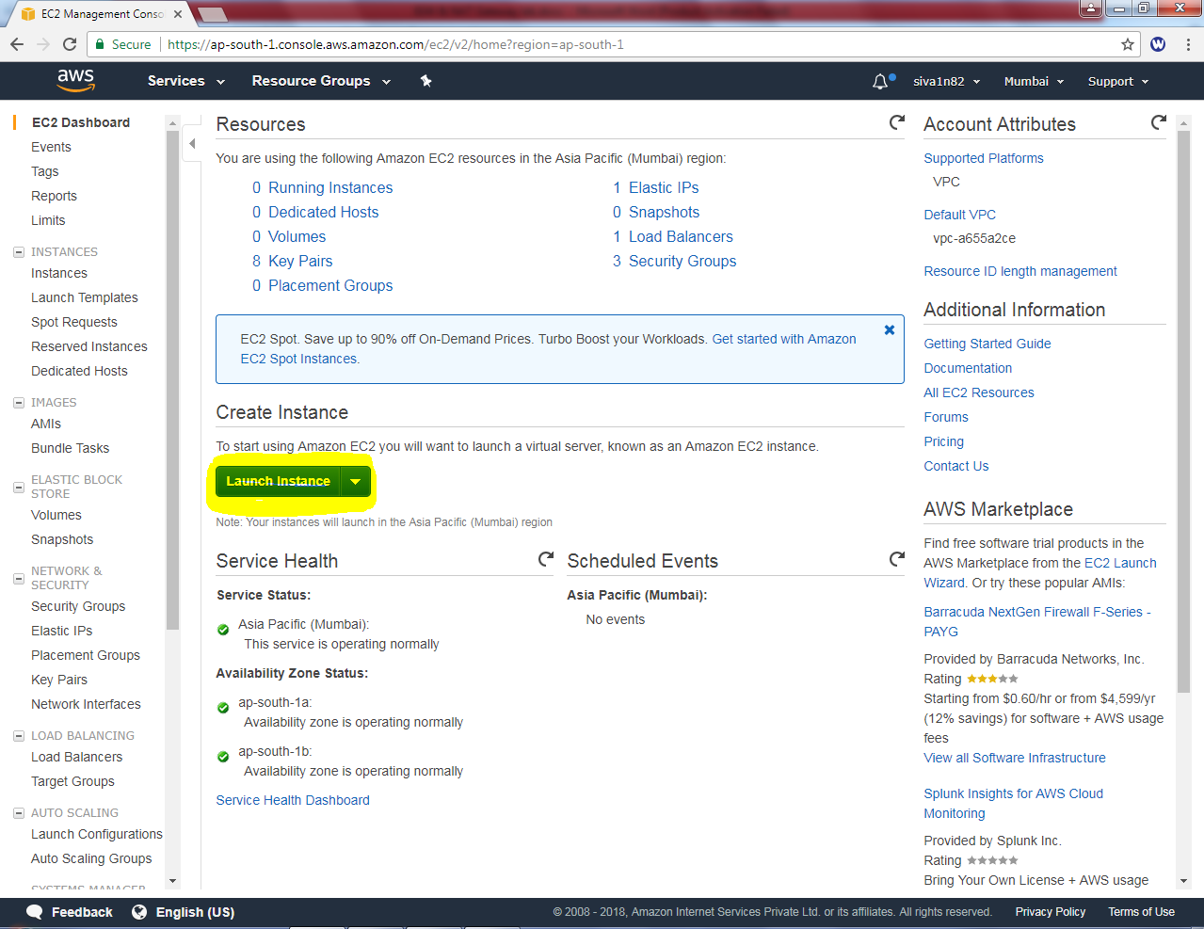

**Select “AMI”**

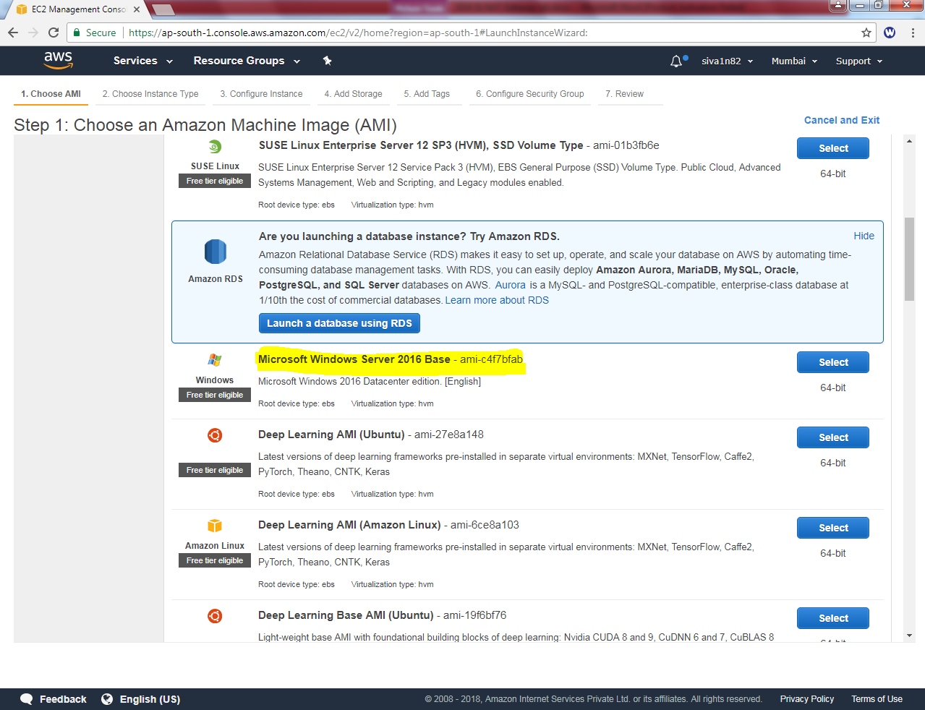

**Select “General Purpose – t2 micro” then click “Next”**

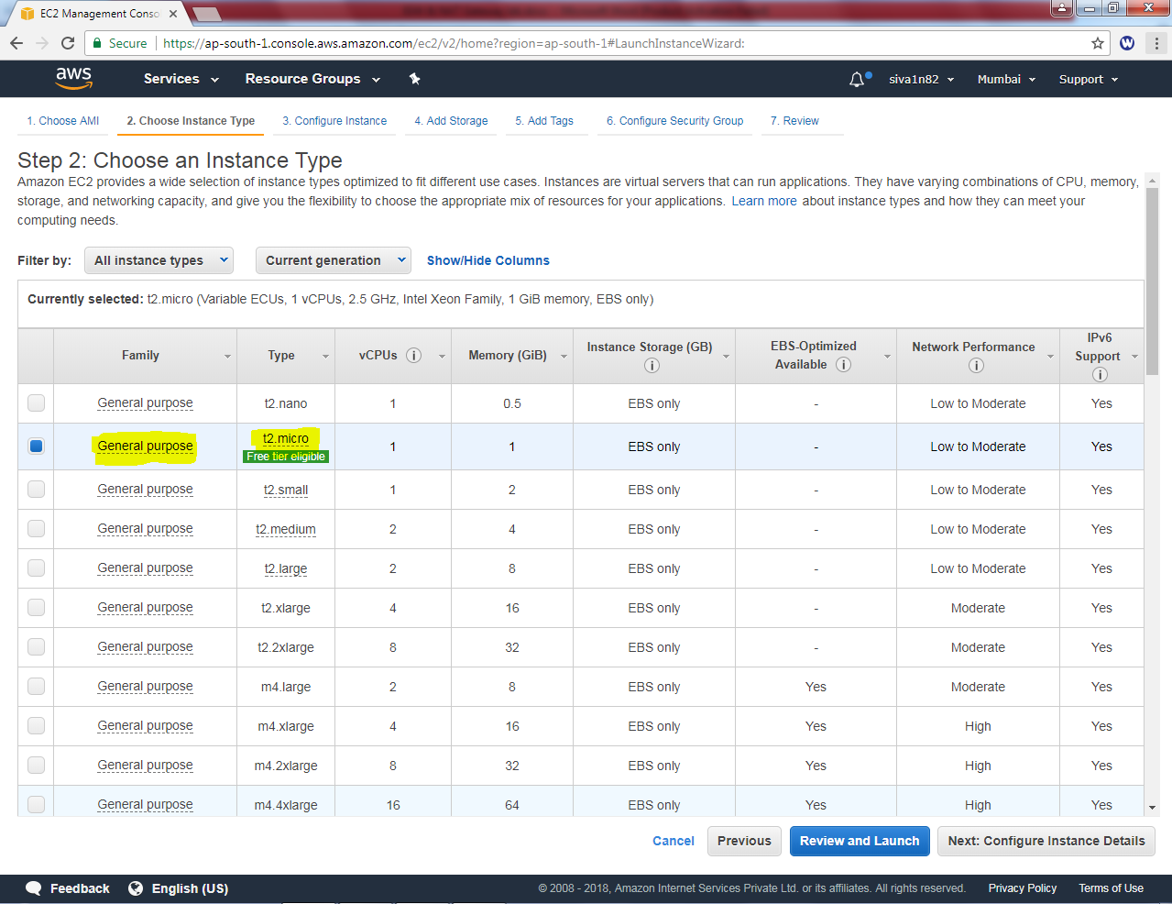

**In Network, select “Siva_VPC”, in subnet select “Siva_Public_network” and in Auto assign Public IP “Enable”.**

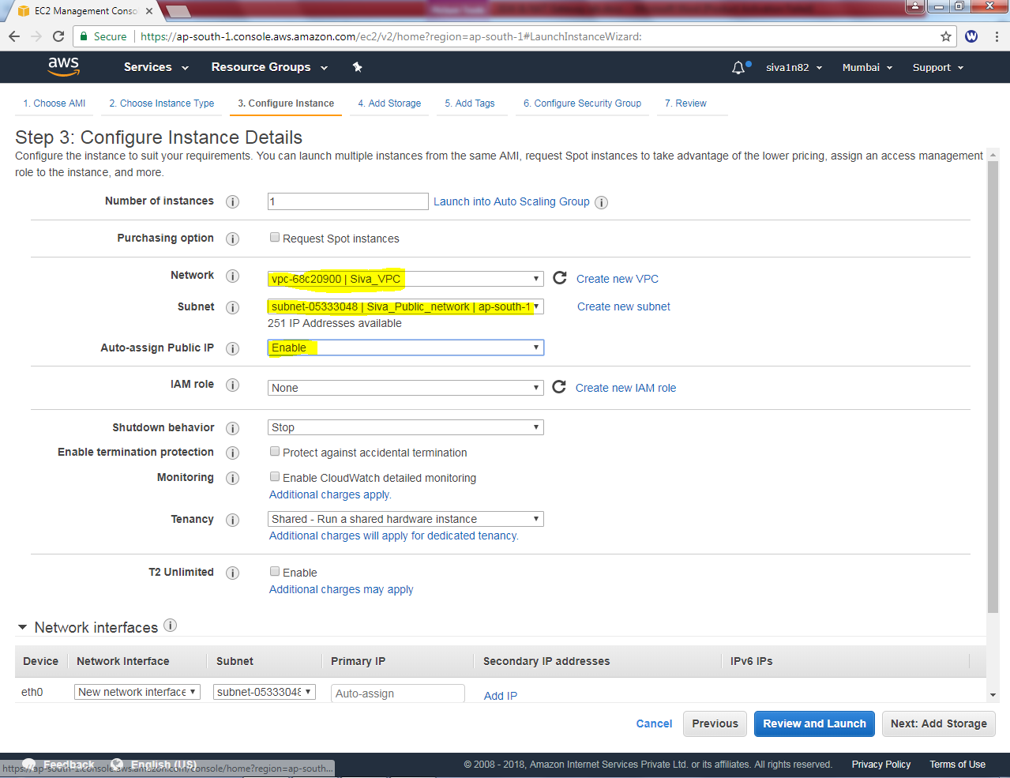

**Then click “Next”**

**Leave this setting by default.**

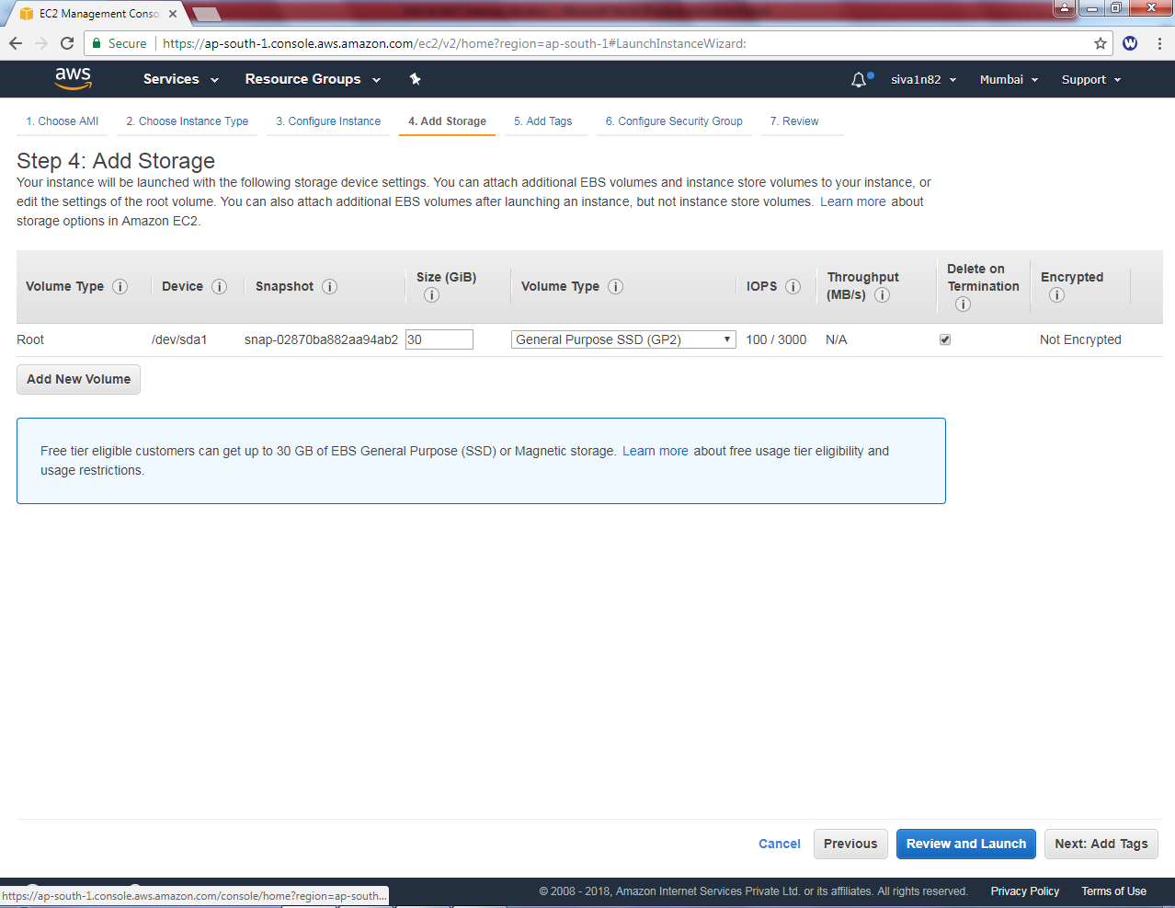

**Then Click “Next”.**

**In Key “name” and in value “Public Instance”.**

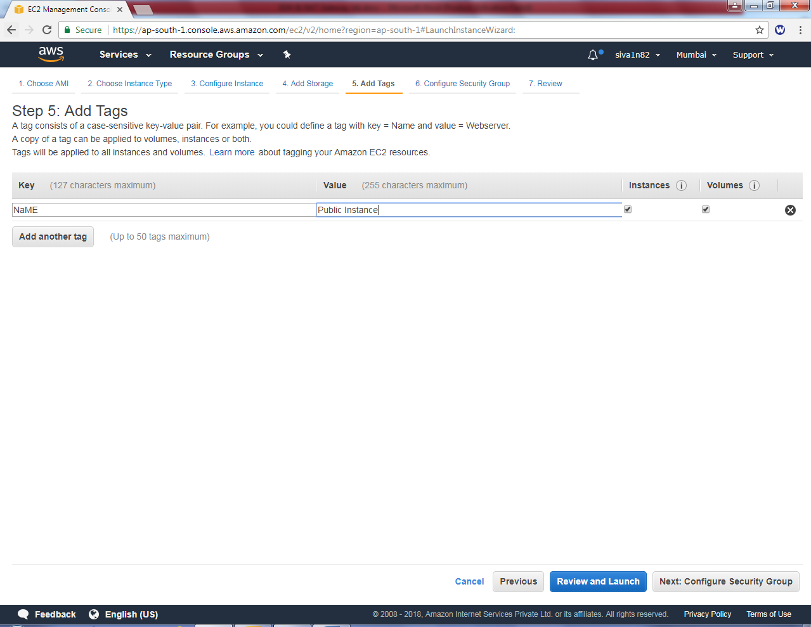

**Then click “Next”.**

**In Assign a Security group click “Create a new security Group”**

**Security Group name: Siva_Public_Sec_Group**

**Description: Siva_Public_Sec_Group**

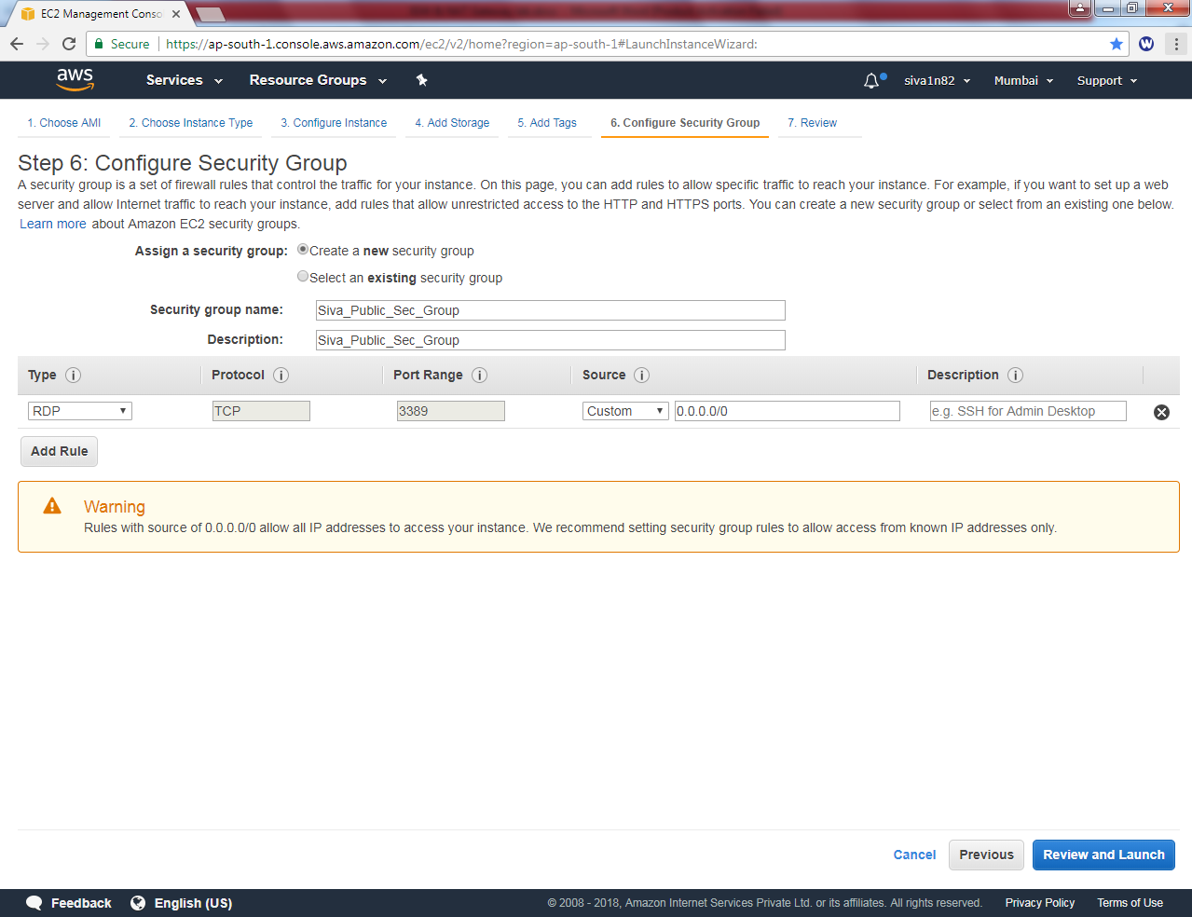

**Click Review and Launch.**

**Leave the settings default.**

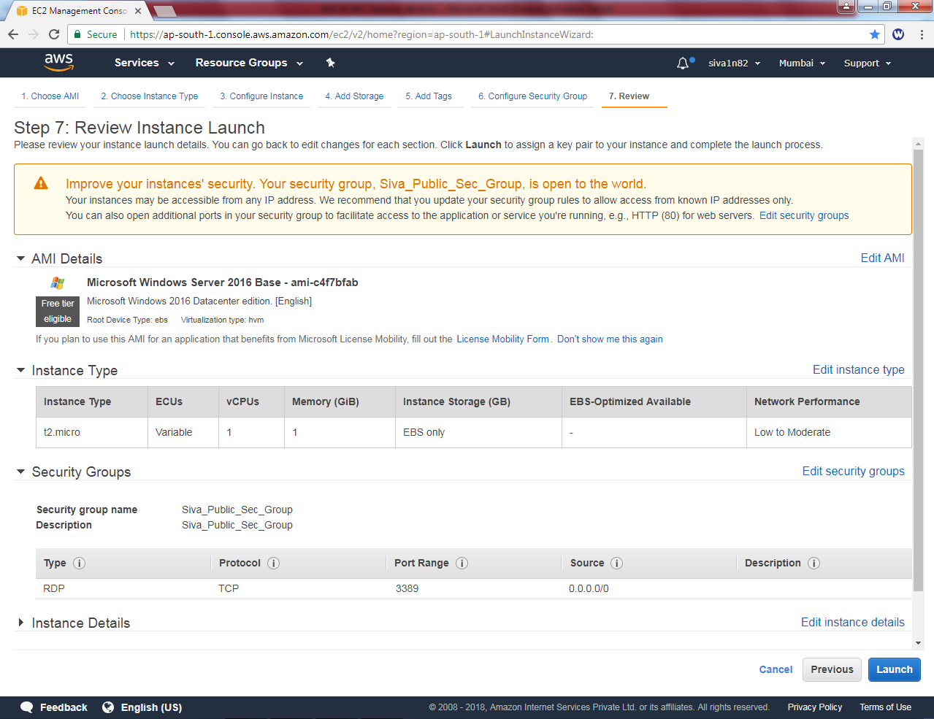

**Click Launch.**

**While click launch, need to select the Choose an existing key pair and select the key pair as “siva_vpc” and Select the option I acknowledge.**

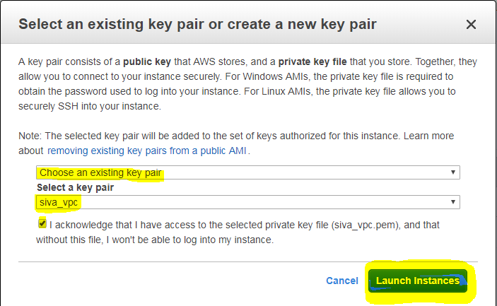

**Then click launch instance.**

**Now, public instance is ready and we have got public IP also.**

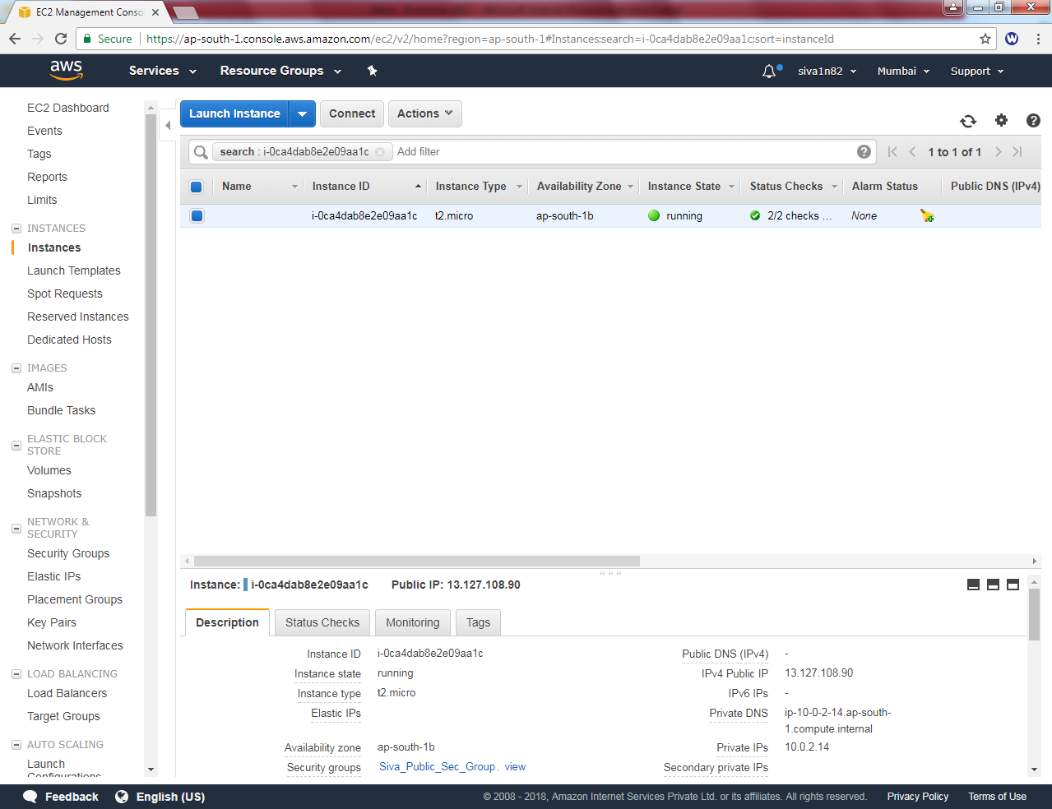

**Now we can try to RDP for 13.127.108.90 IP.**

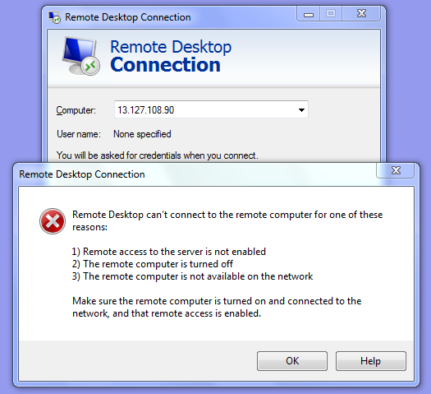

**While try to connect 13.127.108.90 IP, we are getting an above error message.**

**What could be the reason of unable to connect RDP?**

**We have required Internet gateway to connect outside network from Public Subnet. Hence we need to create an internet gateway.**

**Goto VPC Dashboard, we can able to see an Internet Gateways option.**

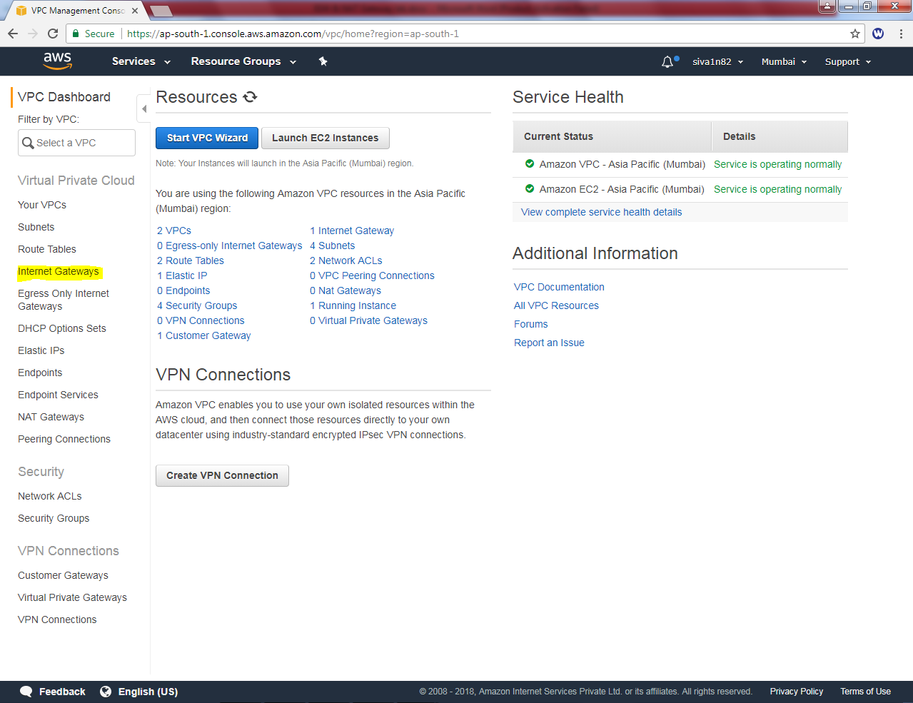

**Click the Internet Gatweways in VPC Dashboard,**

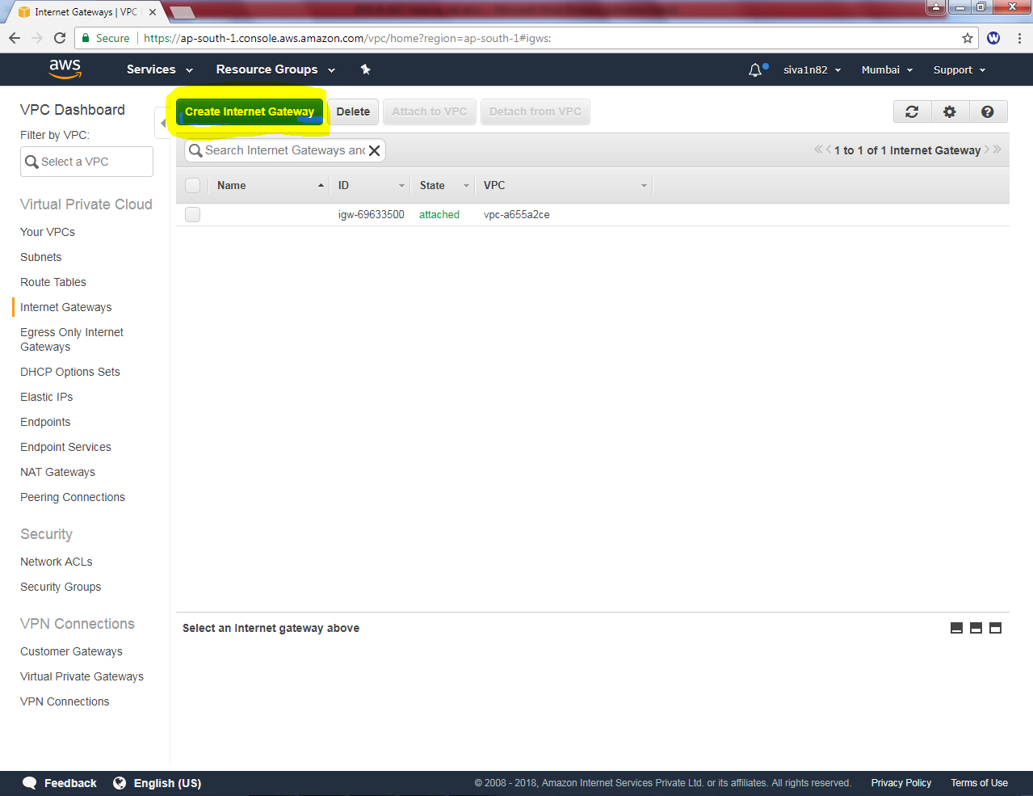

**Click “create Internet Gateway”.**

**In Name Tag, Type “Siva IGW”.**

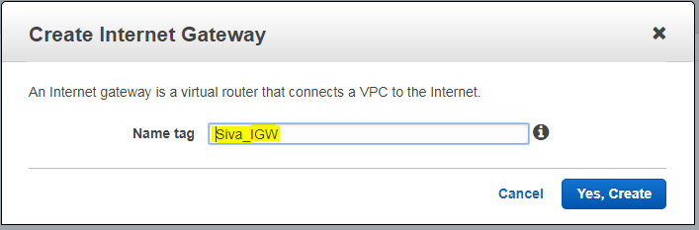

**Then click “Yes, Create”.**

**We can able to see “Siva IGW” option. But it is detached mode.**

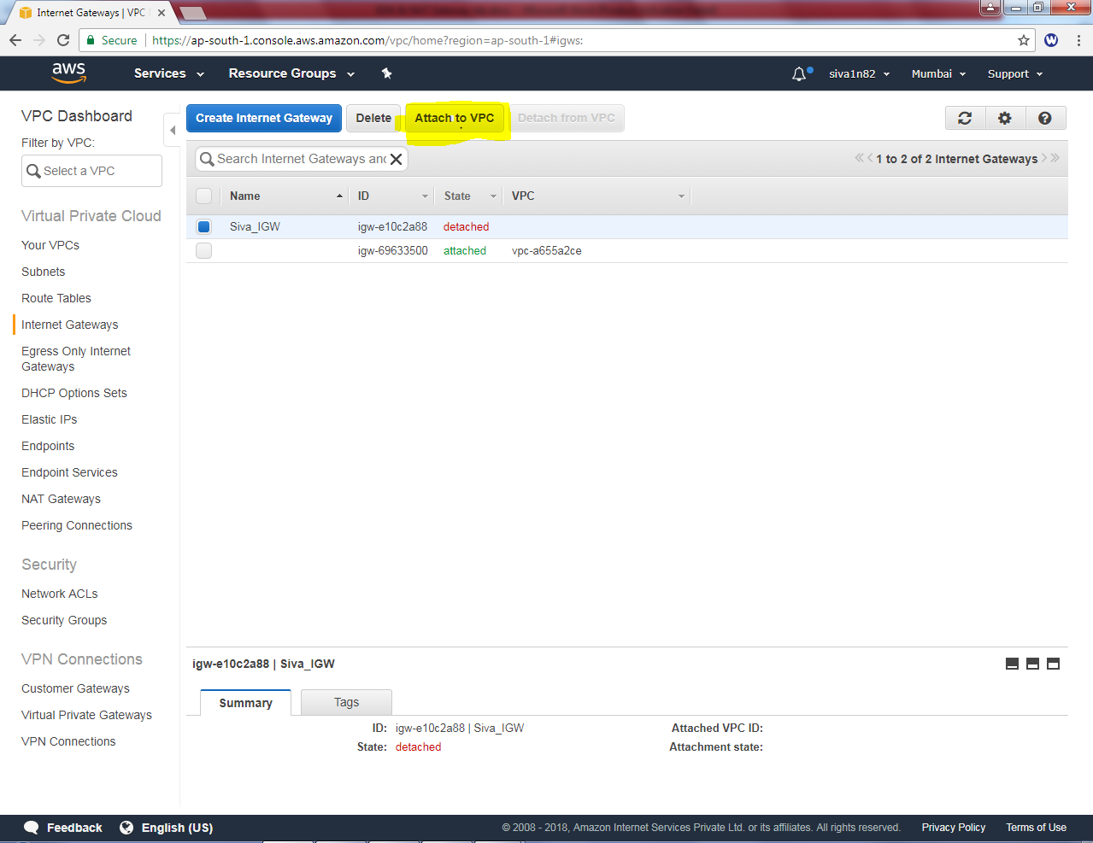

**We need to attach VPC into that i.e. Siva_VPC.**

**In Attach to VPC, Siva_VPC is selected,**

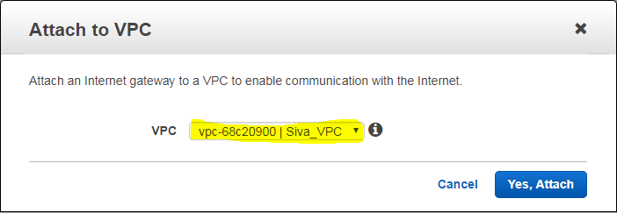

**Click Yes, Attach button.**

**We need to create route table for Public subnet. In Name tag “Siva_Public_route_table”. Then select VPC as “Siva VPC”.**

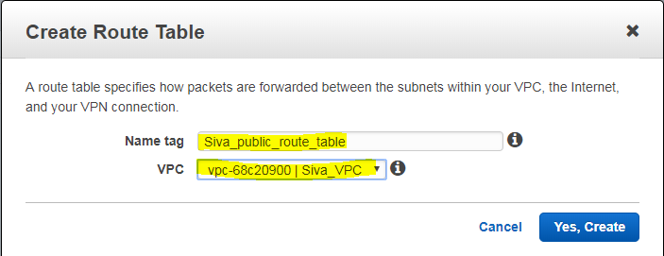

**Click “yes, create”.**

**By default, 10.0.0.0/16 subnet route only available.**

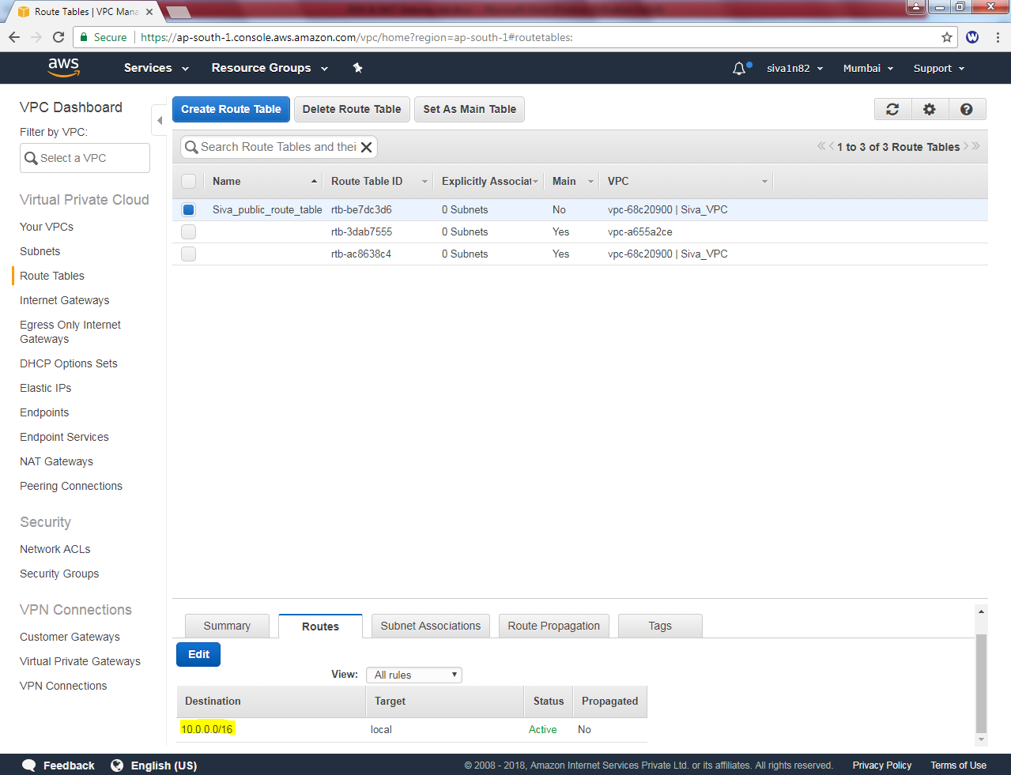

**Click Edit option in route table.**

**Then click “add another route”.**

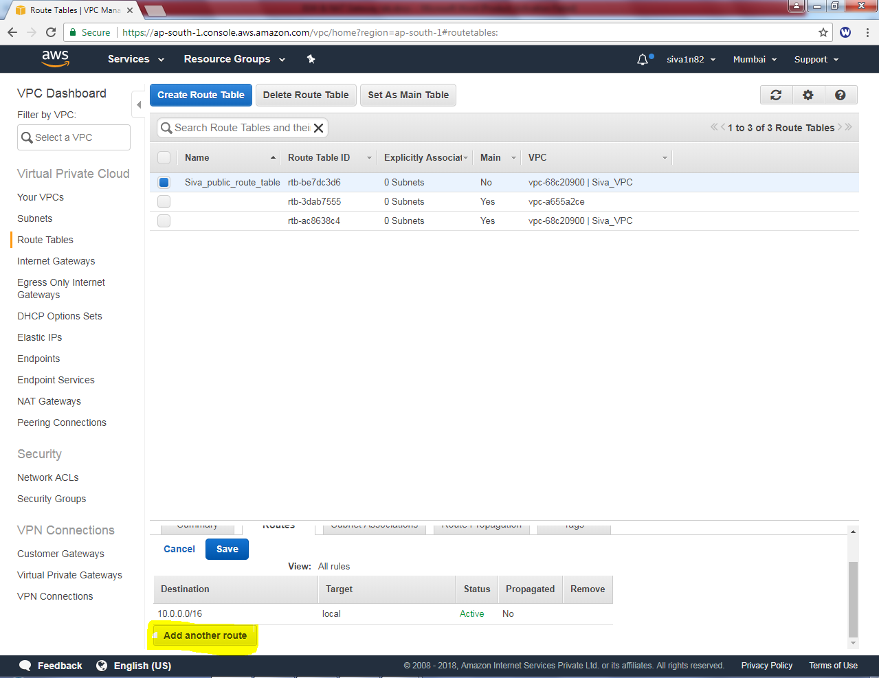

**In Public route table, add default route 0.0.0.0/0 with next hop address as igw (internet gateway).**

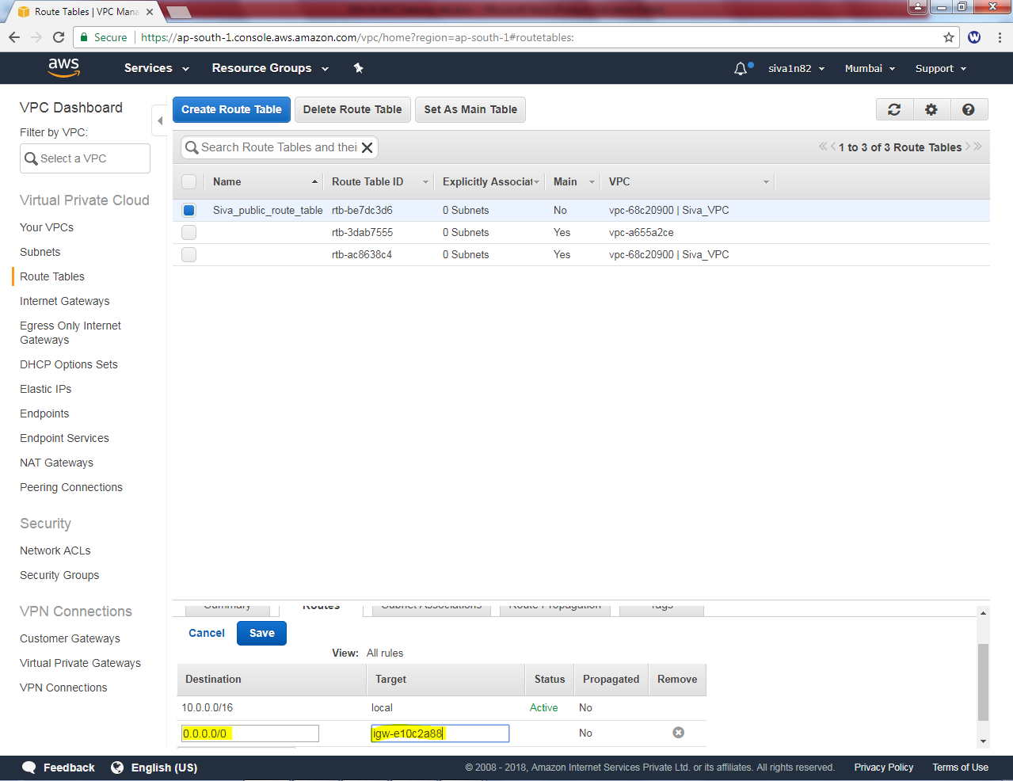

**Then Click “Save”.**

**In Subnet associations, click edit option.**

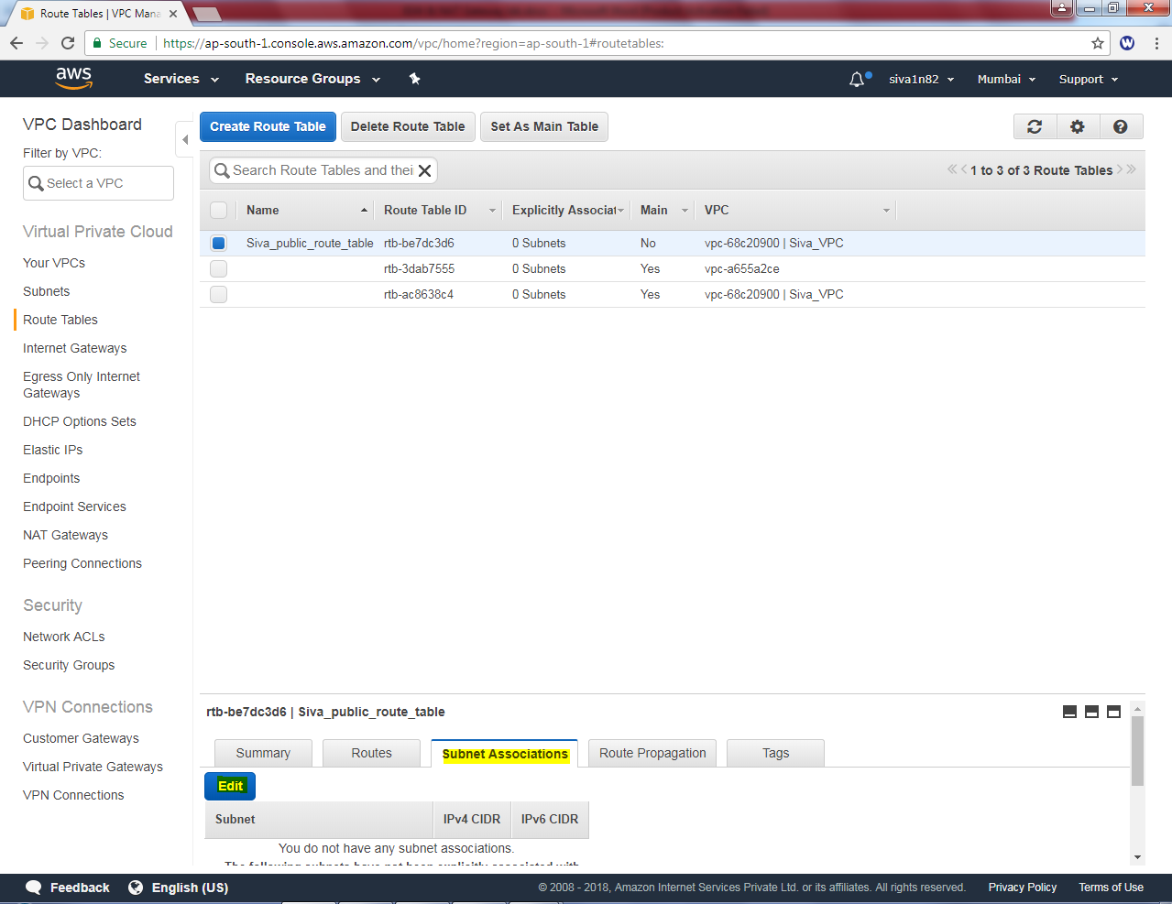

**In Edit option, select “Siva_Public_network”.**

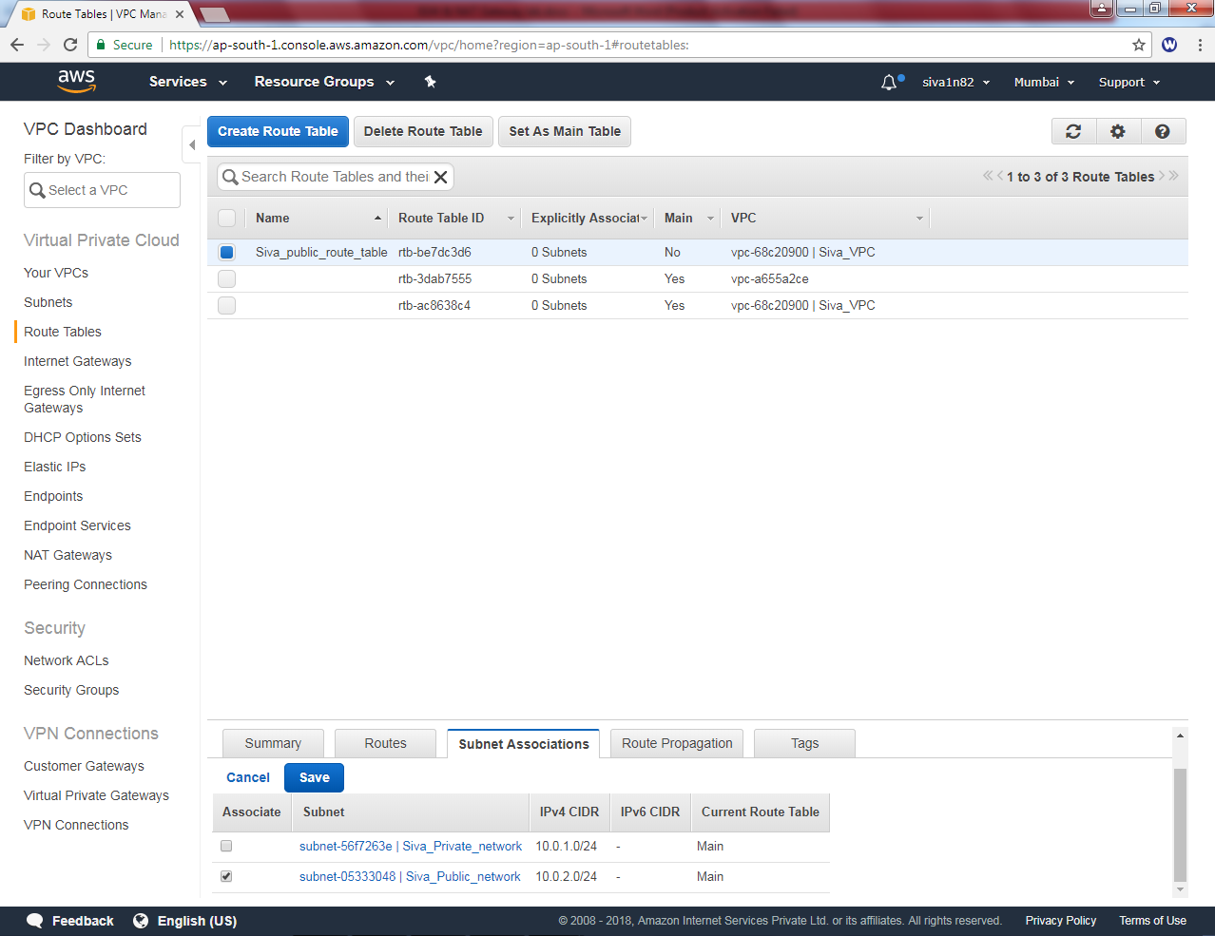

**Then click save.**

**Now you Can try to connect internet, it will work.**

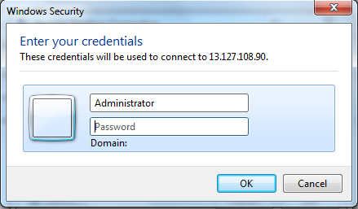

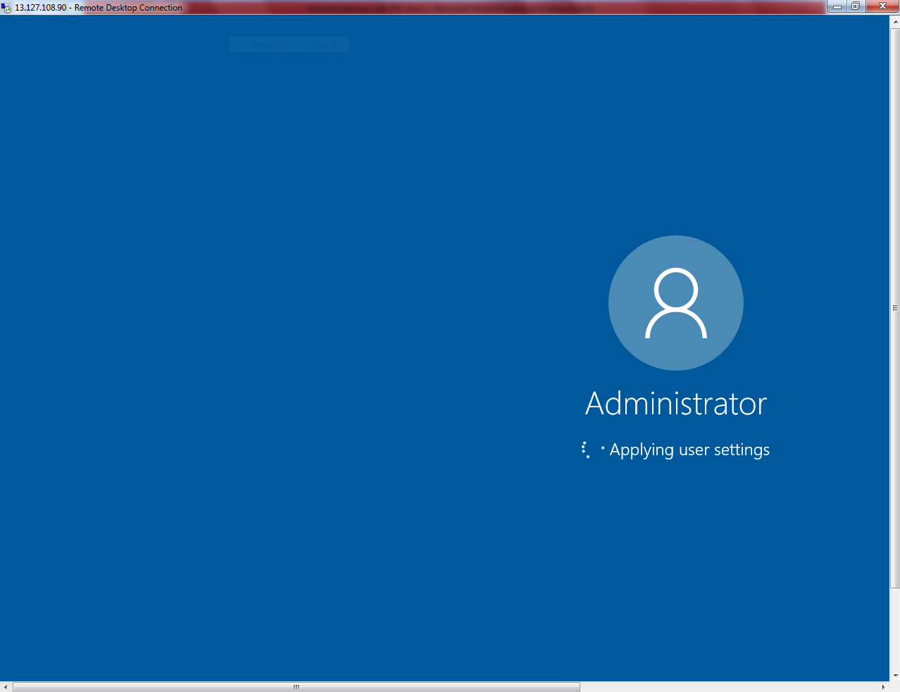

**You have successfully logged into the public server (windows server 2016).**